Different Game Design Document
Jesse Talavera-Greenberg

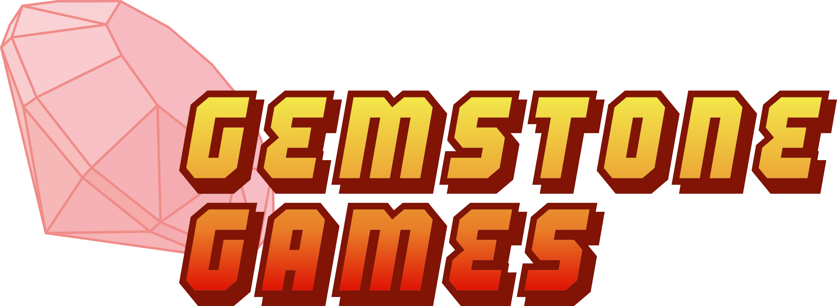

License
This design document is licensed under the Creative Commons Attribution-NonCommercial-ShareAlike 3.0 Unported license. For more details, please refer to the text of the license at http://creativecommons.org/licenses/by-nc-sa/3.0/.

About
Different Game is a puzzle game in the manner of Same Game. You are given a grid of blocks in differing colors, and must click a group of like-colored blocks to clear them. After they are cleared, you are awarded points, and all blocks above fall. If there is a gap in the playing field, the blocks on the left move to the right until one block is adjacent to another.

The difference is, in this game every time you clear a set of blocks, gravity rotates by 90 degrees counterclockwise. This tumbles the blocks around, providing an interesting play experience. Also, this game is not timed.

Main Menu
The menu is simple. It is controlled entirely with the mouse. In the lower left corner, the logo for Gemstone Games will be displayed underneath the Quit button. To the left will be the buttons, some of which are overridden by game information in-game. To the right is the playing field itself. On the next page is a mockup.

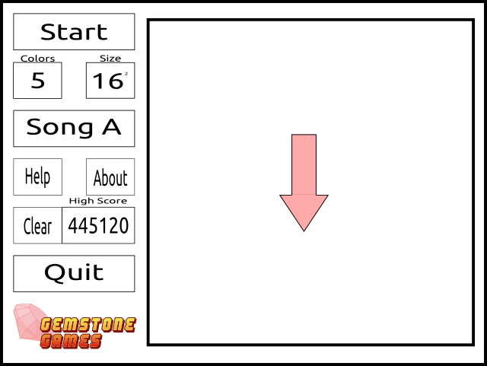

Main Menu Options:
- Start
  - Begins the game on the settings the user has chosen (see below).
- Two buttons with numbers, each cycling through a set of values.
  - Number of blocks (4 to 7)
  - Size of grid (8x8 to 32x32, in multiples of 8)
- Music
  - Pick from one of three songs, none, or cycle through the entire music folder.
- How to Play/About
  - Shows instruction or information text respectively on top of the game field. Only shown as long as the mouse button is held down.
- Clear this Score
  - Prompts the user to destroy the high score for these settings. Does so with a button on the other side of the screen (so that nothing is accidentally pressed). Sits beside high score.
- Quit
  - Exits the game.
In-Game Menu Options/Displays:
- Score
  - Scoring is detailed in a later section. Replaces “Start”
- Block and Size information
  - Greyed out and cannot be modified. Only for show.
- Music
  - May still be changed. Clicking any button changes the song, even the “cycle” button. “Cycle” starts from the highest-named music file.
- How to Play/About
  - Same as in the main menu.
- High Score
  - Shows the highest score for this mode.
- End Game
  - Ends the game. Ask the user for confirmation first, same as with clearing the score.

Interface Design
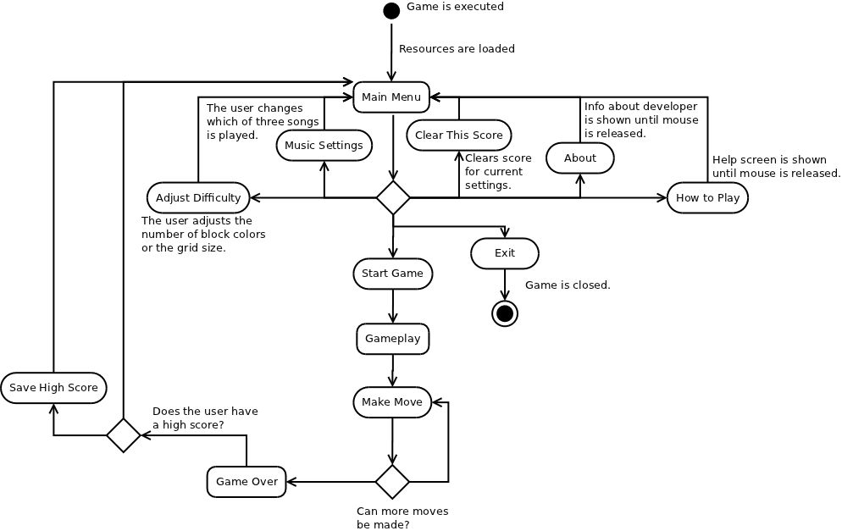
The game takes place on just one screen. To the right is the field of play, empty at the beginning save for an arrow (which points in the direction of gravity). To the left are the menu options, which are replaced by game statistics and other buttons as detailed above. The game flows as shown below:

Gameplay and Scoring
As mentioned, the goal is to score as many points as possible by clicking tiles that reside next to ones of a like color. The game ends when no like-colored tiles are adjacent to each other.

The user gives input by clicking the blocks twice. The first time they are highlighted, blinking brightly. The second time they are actually cleared. After a set of blocks is destroyed, gravity turns 90 degrees counterclockwise, starting from the usual downward direction.

Scoring is fairly simple. The player receives (n-1)³ points for each set cleared (where n is the number of blocks). At the end, the score is divided by how many blocks remain plus one (to avoid dividing by zero). If he has cleared all blocks, the player's score is increased by 50%. This is the player's final score.

There is just one high score for each configuration, to be saved in a SQL database. Each one may be cleared individually.

The F3 key takes a screenshot. The F4 key changes from windowed to full-screen mode. There is no undo functionality.

Graphics
- The frame that surrounds the game screen and buttons will be similar to a brick wall. The game frame is similar, but more recessed.
- In the center of the game window is a large window that peeks outside. In front of it is an arrow that rotates to show which way is down. The arrow also changes color depending on its direction.
  - The four directions represent the four seasons. From down, counterclockwise, we have fall, winter, spring, and summer. The weather shows this by having different things falling down, with respect to gravity.
  - From fall on, there are leaves, snowflakes, cherry blossoms, and rain showers. The sky also changes color, grey during the winter and dark blue during the summer.
  - The weather changes at the exact same time the blocks begin to fall.
- The buttons are fairly simple, similar to billboards. Nothing special here.
- The blocks are to be similar to kitchen tiles. There will be just one block image (white), which will be tinted in various colors by the game, depending on the settings. They will be scaled depending on the size settings. Available colors will be red, blue, green, yellow, purple, teal, and white.

Sound
- The music will be calm and cheery, sort of like Puzzle League's. At least one song will be in chiptunes.
- There will be sound effects for the following:
  - Button is clicked
    - A simple “click” sound.
  - Block is clicked.
    - A brief “ping”!
  - Block is destroyed.
    - This is an explosion.
  - Block hits the ground or another block.
    - A “thud”
  - Arrow spins.
    - Sounds like something winding up.
  - Gravity and weather changes.
    - Some kind of sci-fi sound.
  - Game Over jingle
    - Gives more of a “That's a wrap!” vibe than a “You lose!” one.
      - Perfect score gets more congratulatory jingle.

